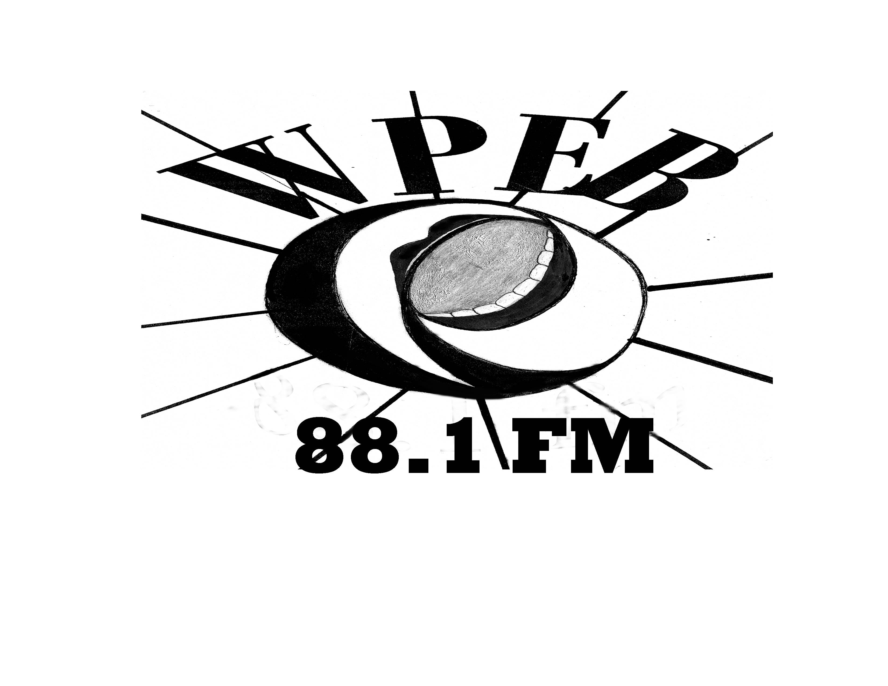

West Philadelphia Community Radio

541b S. 52nd Street • Philadelphia, PA 19139

Studio: (215) 472-0881 • Office: (215) 222-4201

email: inquiry@wpeb881fm.org
website: www.wpeb881fm.org

WPEB 88.1fm is a member supported, noncommercial community radio station providing West Philadelphia a much needed local, progressive, and accountable media outlet to serve as a voice for its many diverse communities.

WPEB MEMBERSHIP APPLICATION

In order to become a member, you must:
- Attend at least two General Monthly Meetings (first Monday of every month);
- Be active on a radio committee (Fundraising, Outreach, Programming, or Technology); and
- Pay an annual membership due, on a sliding scale from $25 - $50.

By becoming a Member, you:
- Will receive email notification of station news and events;
- Are able to vote on decisions that affect WPEB’s procedures and policies;
- Help support the station and its growth; and
- Receive a WPEB Membership Card

MEMBER CONTACT INFORMATION

(Please detach, complete and fax to 215-222-4205 or send by mail to:
WPEB • c/o Scribe Video Center • 4212 Chestnut Street, 3rd Floor • Philadelphia, PA 19104)

NAME: DATE:

ADDRESS: ORGANIZATION:

EMAIL: PHONE:

SIGNED UP BY: BEST TIME TO BE REACHED:

COMMITTEE of INTEREST (check as many as apply):
□ Fundraising □ Outreach □ Programming □ Technology □ Facilities

