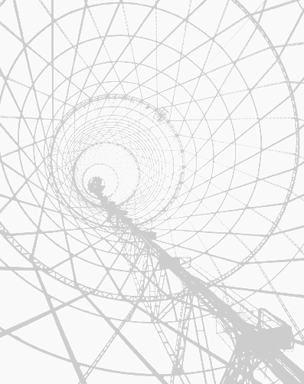

www.wpeb881fm.org
studio: (215) 472-0881
info: (215) 222-4201

WPEB 88.1 FM
LET YOUR VOICE BE HEARD!
WPEB is a program of Scribe Video Center, working in partnership with Prometheus Radio Project and the Independent Media Center of Philadelphia (Philly IMC), with support from community members, organizations, artists and listeners. In addition, WPEB has received support from the Ford Foundation, the Philadelphia Foundation, Nathan Cummings Foundation, Bread and Roses Community Fund – Media Justice Fund, Samuel S. Fels Fund, Anonymous Donor, and Robert Brand and Elizabeth Werthan.

Attend a monthly general meeting
the first Monday of every month:

6:00pm – new member orientation
6:30pm – general meeting

at WPEB Studios, 541B S. 52nd St.

www.wpeb881fm.org
please visit our website to:
View the Station Events and Programming Calendars
Sign up for e-Updates
Contact Committee Chairpeople
View Station Documents
Find More Information

Let your voice be heard.

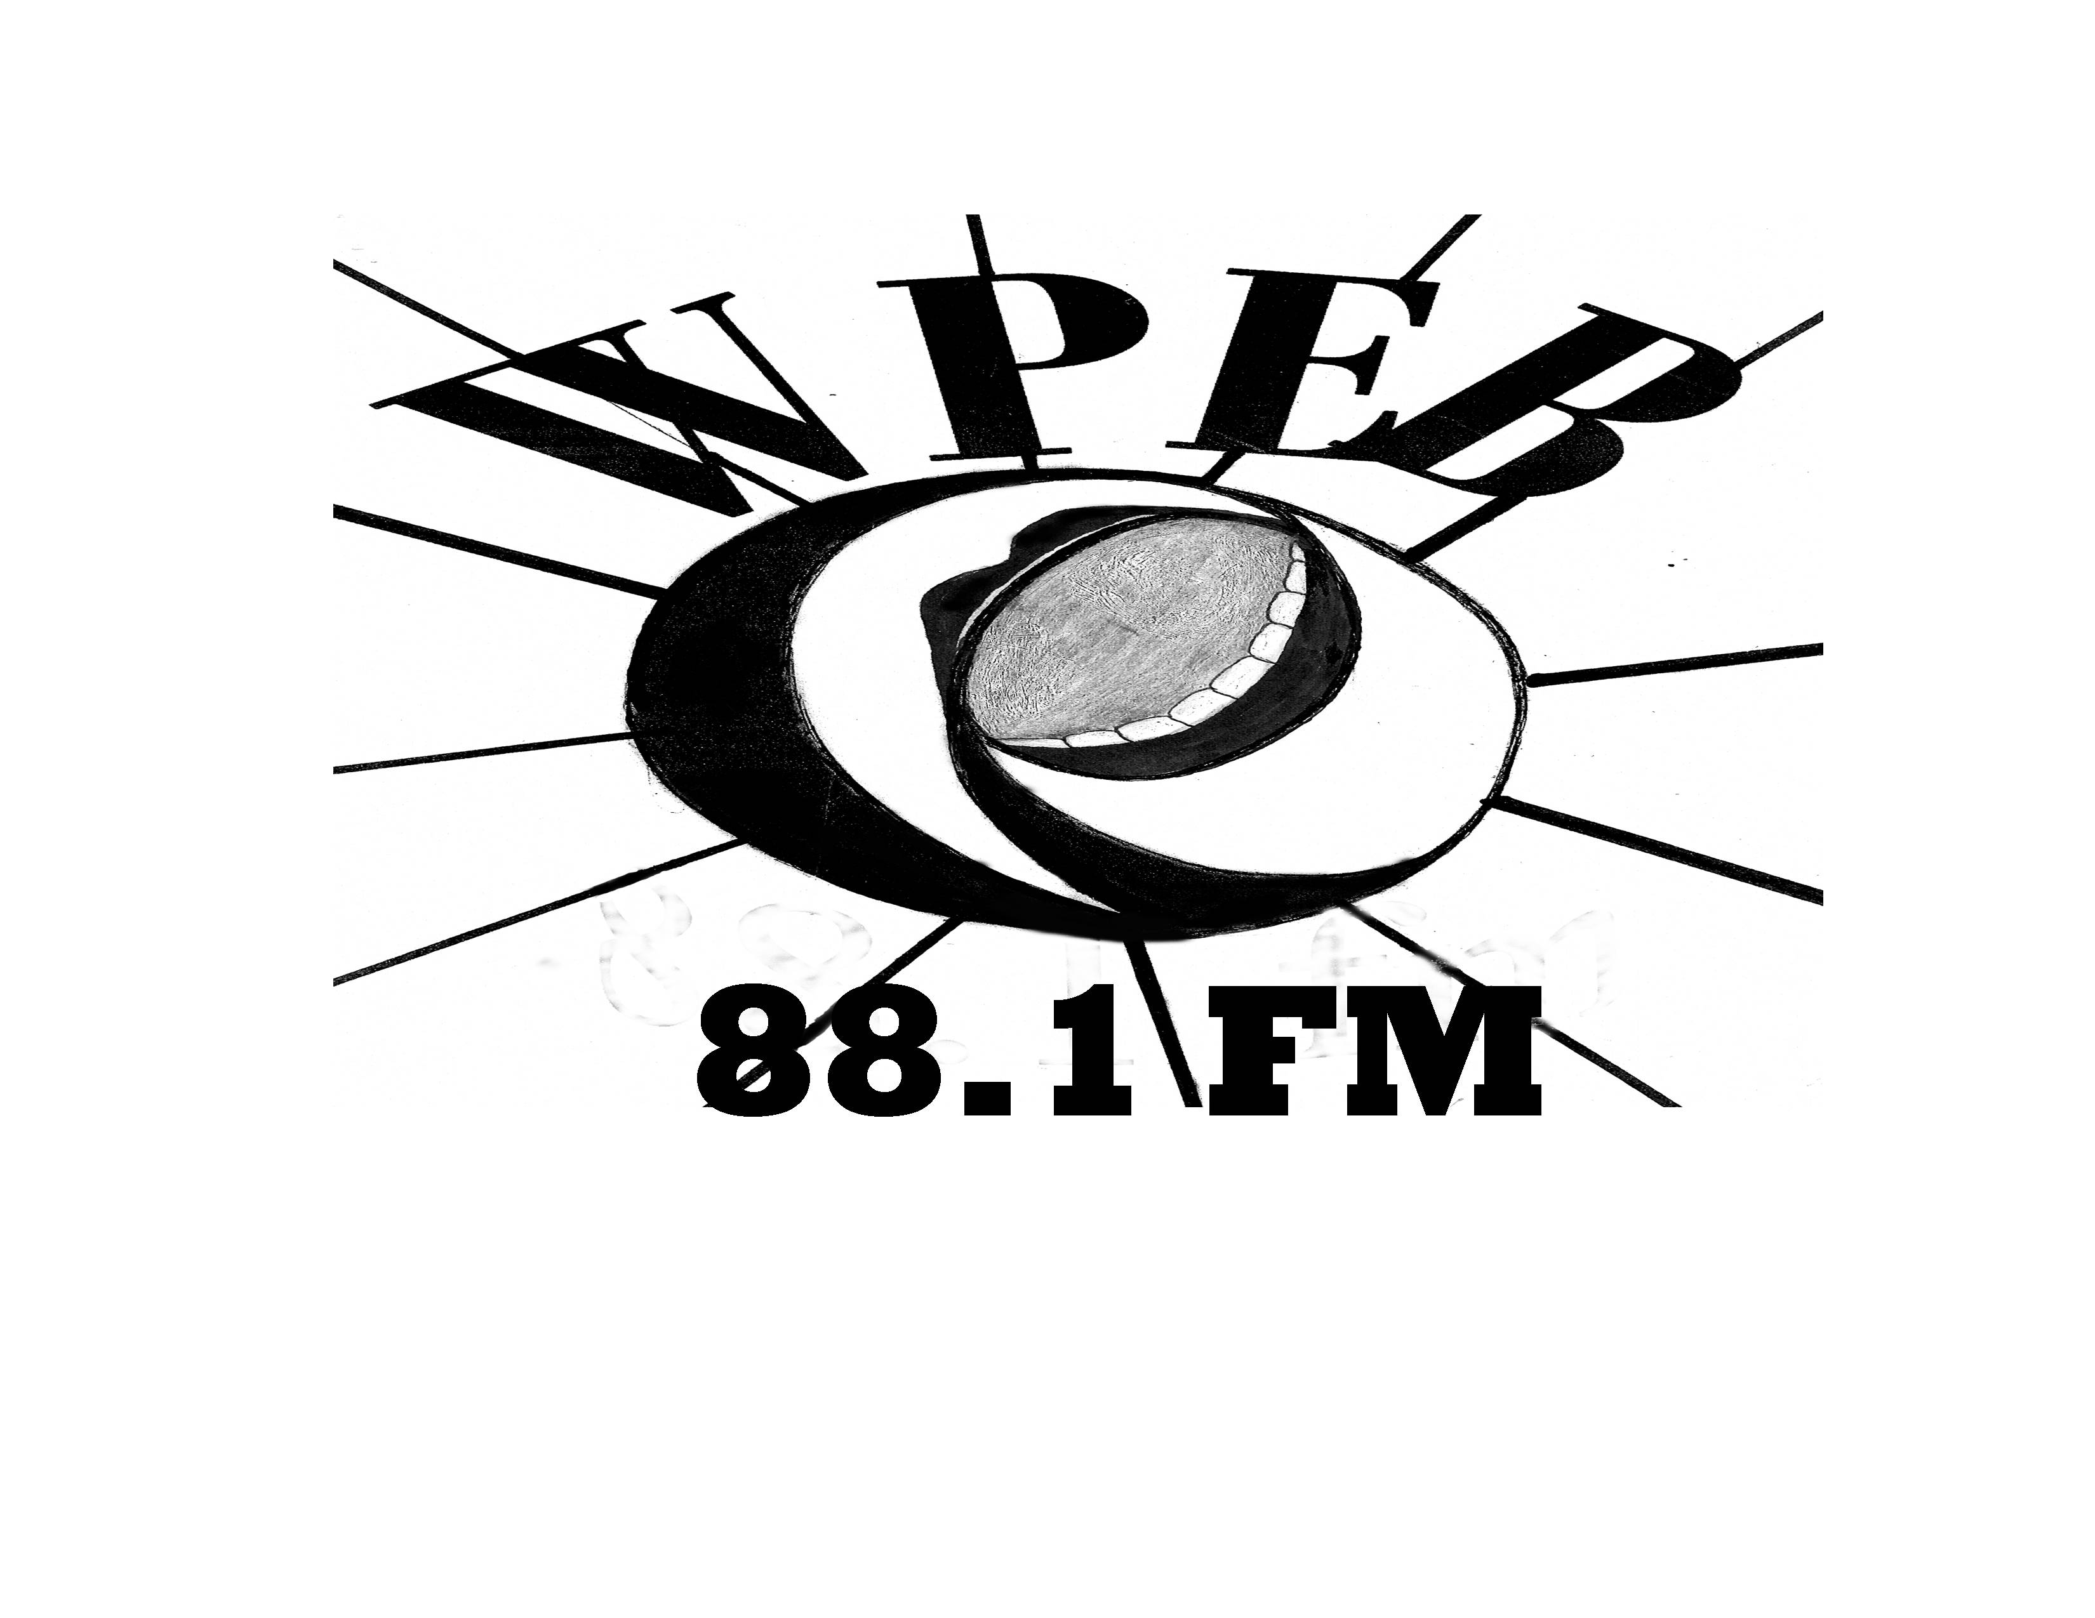

Send payment to:

Scribe Video Center
Attn: WPEB
4212 Chestnut Street
Philadelphia, PA 19104

West Philly’s own
Community Radio

88.1fm
www.wpeb881fm.org

Studio: (215) 472-0881
Information: (215) 222-4201

Studios are located at
541B S. 52nd Street

How do I get involved?

Anyone is welcome to get involved with WPEB! As a volunteer-run project, there’s no shortage of ways to contribute.

- Come to a Monthly Meeting, held every first Monday, for an orientation to the station at 6pm and a general meeting at 6:30.
- Becoming a Member is the best way to help the station. Members pay yearly dues on a sliding scale and volunteer on a station committee.
- Host a Show on a subject or genre of music you enjoy.
- Volunteer as a non-Member on a committee or sign up online as an occasional pair of hands.
- Make a Donation or Underwrite a Show.
- Contribute Public Service Announcements or Community Calendar Events
- LISTEN and spread the word about the station and its mission.

For more information, please contact a chairperson from the website, or call (215) 222-4201.

How can I get a show on the air?

Please contact the Programming Committee Co-Chairs, whose contact information can be found on our website. There, you can also find a copy of WPEB’s Programming policy and download an application. Pending approval, you will receive an orientation, technical training and a trial show. Every show will be reviewed following the end of each year’s term.

How can I become a Member?

To become a voting Member of WPEB you must pay a nominal annual Membership fee, become an active participant in one of WPEB’s working committees, and volunteer at least 20 hours to the project. While the latter two requirements may seem unusual and involved, this policy meant to encourage a reciprocal commitment between WPEB and our community.

- Membership is $20 - $50 on a sliding scale.
- Student and Senior Membership is $5 - $25 on a sliding scale.
- Institutional Membership for local organizations and businesses is $200 - $1000 on a sliding scale.

You can also become a non-member Friend of WPEB by donating any denomination.

BECOME A MEMBER
OF WPEB TODAY!

Name ___________________________________
Address _________________________________
________________________________________
City/State/Zip ____________________________
Phone __________________________________
Email ___________________________________

- Membership ($20 - $50)
- Student and Senior Membership ($5 - $25)
- Institutional Membership ($200 - $1000)
I would like to volunteer for one or more of the following committees:
- Outreach
- Programming
- Fundraising and Finance
- Technology

Payment Type:
Cash Credit Check
Amount $ __________________________
Checks must be made out to Scribe Video Center, with “WPEB Membership” in the Memo line. Scribe Video Center is a registered 501(c)(3) nonprofit organization.
What is community radio?

WPEB 88.1FM is an independent, noncommercial community-based radio station dedicated to celebrating West Philadelphia’s unique qualities and serving its diverse community by:

- Providing a forum for issues, artists and organizations who have been overlooked, suppressed or misrepresented by other media.
- Promoting communication, education and entertainment through programming that is interactive between the station and the community.
- Providing training that facilitates creative expression and exploration of public issues with the goal of empowering members of the community.

WPEB’s programs and content are determined by our Members; NOT by advertisers, foundations or government agencies.

As a volunteer-run project, WPEB relies on the commitment and generous support of our Members to sustain our activities. To guarantee that leadership of the station remains in the hands of the community, important decisions are made by the Membership and a community Board of Managers that is democratically elected.

How does WPEB work?

As a noncommercial radio station, WPEB relies solely on the time, energy, creativity, and commitment of its Members. Currently this work is being organized by a number of Member-led committees:

- Outreach informs and recruits local groups and individuals from all over West Philly.
- Programming coordinates WPEB’s programs through outreach, orientation, and training.
- Fundraising increases WPEB Membership base, coordinates underwriting efforts, solicits grants, and plans fun community events.
- Technology maintains the studio equipment, provides training to members, and fixes equipment problems.

To join a committee, please contact its chairpeople (info online) or call (215) 222-4201 and you will be invited to the next meeting.

